*Heaven’s light is our guide.*

**Rajshahi University of Engineering and Technology**

**(RUET)**

**Department of Electrical & Electronic Engineering**

**Course no.** EEE2204

**Course title:** Electronics III Sessional

**Experiment no.** 02

**Experiment name:** Experimental study of a clipper circuit using passive elements.

**Submitted to:**

**Dr. Md. Samiul Habib**

Associate Professor

Dept. of Electrical & Electronic Engineering,

Rajshahi University of Engineering and Technology.

**Submitted by:**

**Ashraf Al- Khalique**

Roll: 1801171; Session: 2018-2019

Dept. of Electrical & Electronic Engineering,

Rajshahi University of Engineering and Technology.

**Date of experiment:** January 21, 2021.

**Date of submission:** January 28, 2021.

**Experiment no**. 02

**Name of the Experiment:** Experimental study of a clipper circuit using passive elements.

**Objectives:** Followings are the main objectives of this experiment,

1. To understand the theory of operation of the clipping circuit using passive elements.
2. To study the diode applications in a clipping circuit using passive elements.
3. To observe wave shapes that meet the clipping circuit’s needs.

**List of Components:**

1. AC voltage source (10Vpk, 100Hz, 0o)
2. DC power supply (5V)
3. Resistors (1kΩ; 1 piece)
4. Diode (1N 4007; 1 piece)
5. Oscilloscope
6. Project board
7. Connecting wires

**Circuit diagram:**



***Fig 1.1:*** *Circuit diagram for Biased series clipper circuit.*

**

***Fig 1.2:*** *Circuit diagram for Biased parallel clipper circuit.*

**Wave shape:**

1. **Biased series clipper circuit:**

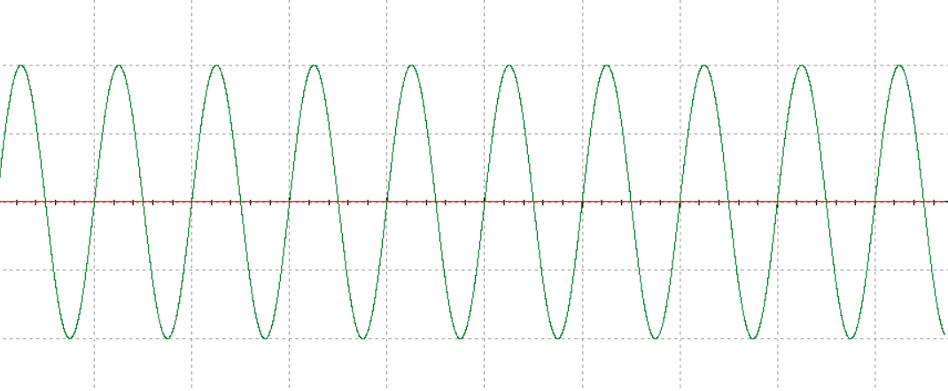

***Graph 1.1:*** *Input signal for biased series clipper circuit.*

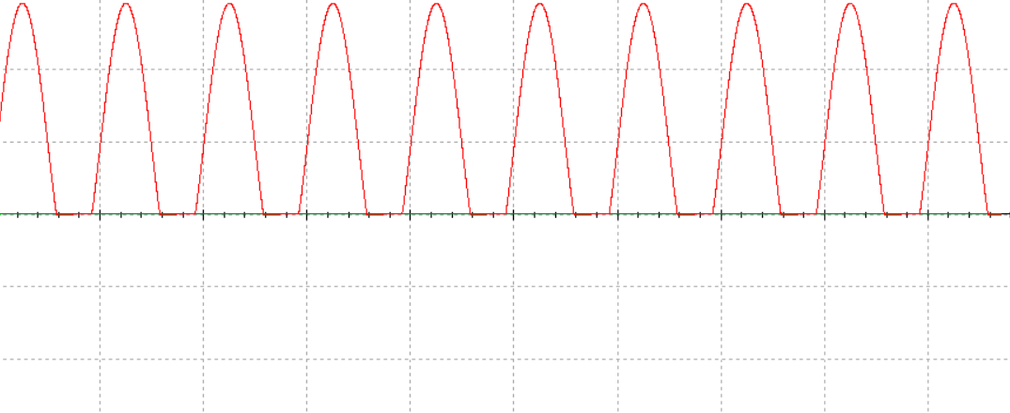

***Graph 1.2:*** *Output signal* *for biased series clipper circuit.*

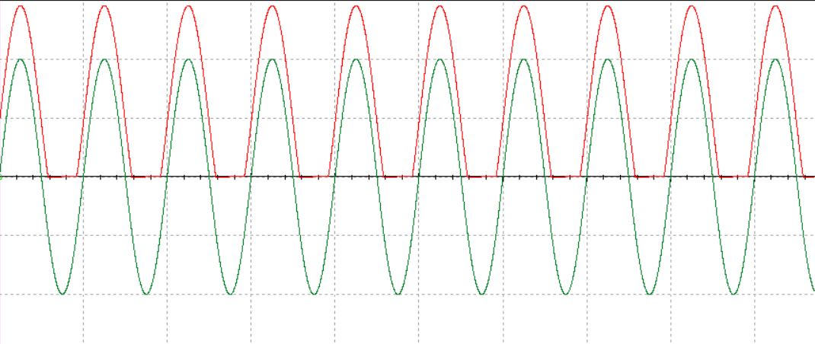

***Graph 1.3:*** *Input and output signal for biased series clipper circuit.*

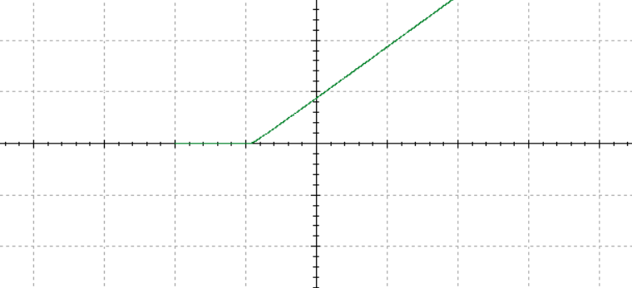

***Graph 1.4:*** *Transfer function curve for biased series clipper circuit.*

1. **Biased parallel clipper circuit:**

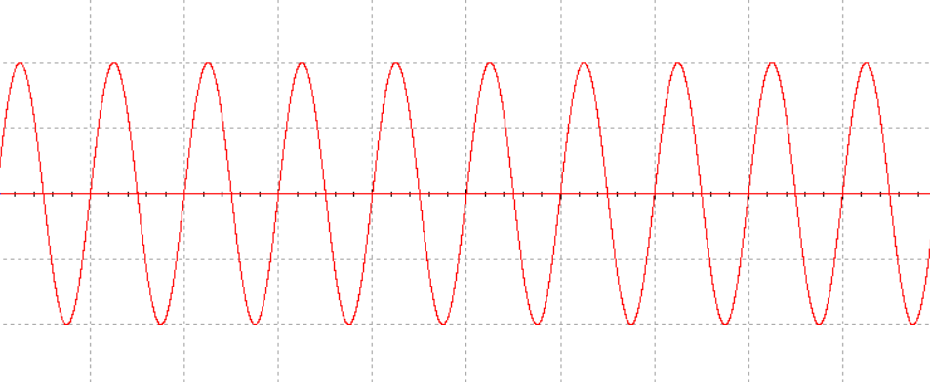

***Graph 1.5:*** *Input signal for biased parallel clipper circuit.*

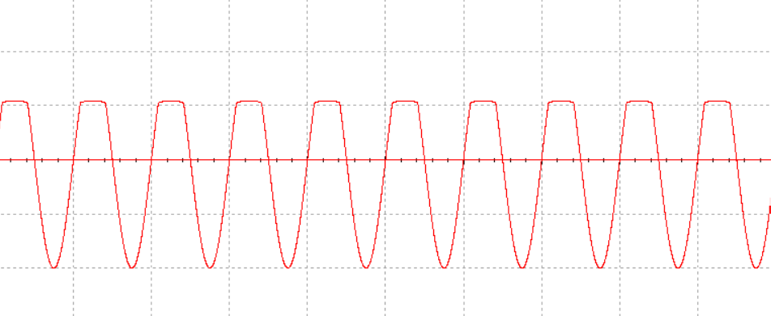

***Graph 1.6:*** *Output signal for biased parallel clipper circuit.*

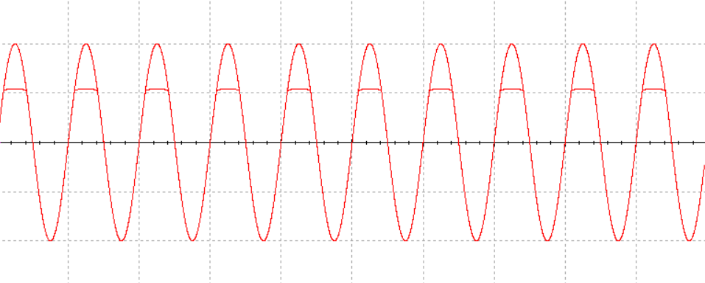

***Graph 1.7:*** *Input and output signal for biased parallel clipper circuit.*

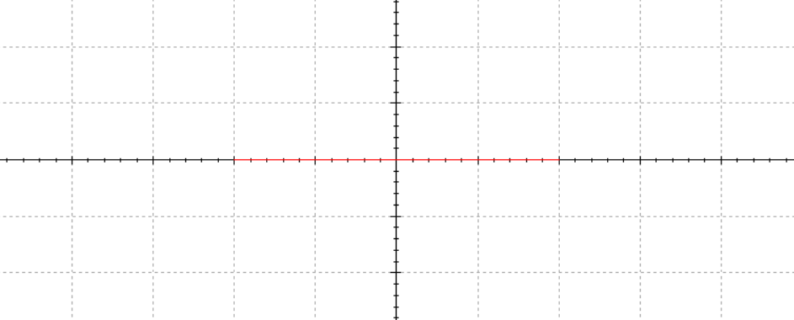

***Graph 1.8:*** *Transfer function curve for biased parallel clipper circuit.*

**Result:**

For a biased series clipper circuit, positive half cycle output was around 14.3V, and for negative half cycle, output was completely clipped off.

For a biased parallel clipper circuit, positive half cycle output was around 5.7V and for negative half cycle, output was 10V.

**Conclusion:**

For a biased series clipper circuit, the AC input signal shifts its origin for the DC voltage. Here, for the positive half cycle, output magnitude was around 14.3V as 0.7V was dropped across the diode. But for the negative half cycle, the output signal was completely clipped off as the diode was in forwarding bias condition. This is because the voltage measured is across the load resistor.

For a biased parallel clipper circuit, the graphical output resembles a negative half-wave rectifier. It is because the voltage is measured across the diode, rather than a load resistor. When the diode is in forward bias, the only voltage measured in the positive portions of the wave is the 5V DC voltage plus the diode voltage which is 0.7V when forward biased. But for the negative half cycle, the diode was open-circuited resulting in an open circuit situation. As a result, the negative magnitude was 10V.